Module 2:

Initializing a Project

Contents

Module Overview 1

Lesson 1: Creating and Configuring Calendars 2

How Calendars Work in Project 2010? 3

Creating a Base Calendar 5

Setting Working Hours and Days 6

Setting Non-Working Hours and Days 9

Setting Calendar Options 13

Saving the Calendar 15

Practice: Creating Calendars 16

Lesson 2: Configuring Schedule/Display Options 17

Understanding Duration vs. Work / Effort 18

What is Effort Driven Scheduling? 19

Understanding Task Types 20

Setting Schedule Options 22

Setting Display and General Options 24

Adding Project Information 27

Working with Timescale 29

Practice: Configuring Schedule/Display Options 31

Lesson 3: Creating and Saving a Project Schedule 32

Creating a New Project 33

Creating a Project from an Excel Workbook 35

Creating a Project from a SharePoint Task List 37

Importance of Naming Standards 38

Setting Read-Only and Password Attributes 39

Saving the Schedule 41

Save and Send Options 42

Practice: Creating and Saving a Project Schedule 44

Summary 45

2

.

# Module Overview



When a new project schedule is to be created, it is important to prepare the schedule to receive the tasks and resources that you will be using during the project. When tasks are entered, calculations start running in the background and it is important that these calculations work the way you intend them to behave.

Each project has the ability to have its own unique set of options and values. With this in mind it is valuable to get the new project off to a good start by having the options and values correct for the unique project schedule being created.

In this module we will address the options, values and settings important to have in place BEFORE the first task is entered into your project schedule.

**The objectives in the lesson are:**

1. Creating and Configuring Calendars
2. Configuring Schedule/Display Options
3. Creating and Saving a Project Schedule

# Lesson 1: Creating and Configuring Calendars



Calendars in Project 2010 will determine when a task may be scheduled within the project schedule. It will also influence what defines a day, a week and a month. The calendars will also work hand-in-hand with the calendar options to determine when and how the tasks will be scheduled.

**In this lesson we will explore:**

1. How calendars work in Project 2010
2. How to create a base calendar
3. How to Set Working Hours and Days
4. How to Set Non-Working Hours and Days
5. How to Set Calendar Options

## How Calendars Work in Project 2010?



There are several types of calendars within the Project 2010 system. The following are definitions of available calendars:

* **Base Calendar**: The base calendar which may be used to as a template to create other calendars. A base calendar may also be used as a Project, Resource or Task calendar.
* **Project Calendar**: The project calendar is the calendar assigned to a project and it defines the project working and non-working days. The default name for the Project Calendar is “Standard”.
* **Resource Calendar**: Each resource will have its own calendar which may be based off of a base calendar or the project calendar. Unique resource calendars may also be created.
* **Task Calendar**: A task calendar is assigned to a task to allow for the scheduling of that task in a unique timeframe. For example: tasks which have to occur on a weekend.

**How the calendars are used by the software:**

**RULE:** *A task will be scheduled based on the Project calendar until a resource is assigned to the task. At that time, the Resource calendar will control the scheduling of most tasks. UNLESS – there is a task calendar assigned which will override the Project and the Resource calendars.*

When a project schedule is created, a default calendar of “Standard” is applied to the schedule. This is called the project calendar for the project. The default values on the Standard calendar are: Monday through Friday which are working days, and working time is 8:00 am to 12:00 pm and 1:00 pm to 5:00 pm daily. No holidays are indicated on the calendar. The Standard calendar is also the calendar that will be viewed in the background of the Gantt Chart views. The Calendar Options work hand in hand with the Project Calendar to determine number of hours in a day or week and these values should be in sync with one another. The Calendar options will be discussed in the next section.

By default, 2 additional calendars are included in Project 2010: a 24 hour calendar and a Night Shift calendar. Either of these may be used as Project, Resource or Task calendars.

**FAQ’s:**

**Q:** Why are there no holidays on the calendars?

**A:** This is an international program. Holidays vary from country to country.

**Q:** Is there the ability to add holidays to a calendar the way they can be added in Outlook?

**A:** No – this is not a capability of the software.

**Q:** Do I have to recreate the calendar for each project?

**A:** No – calendars may be created and saved through the Organizer to use in future projects.

**TIP:** The default calendar name for the system is “Standard”. If a different calendar name is selected, each Gantt view will also require changing because Gantt Chart views are set to display the Standard calendar. This change can be made by right clicking in the Gantt view and select Non-working time and changing to the calendar to be seen in the view. Most users keep the Standard calendar because of ease of use.

## Creating a Base Calendar



Creating a new base calendar gives you the ability to create a calendar with the unique values your projects require. The values of the Standard calendar are:

* Monday through Friday are working days
* Saturday and Sunday are non-working days
* Working time is 8:00 am to 12:00 pm and 1:00 pm to 5:00 pm daily
* No holidays

How to Create a New Base or copy an existing calendar:

1. Click **Project** 🡪 **Change Working Time**
2. Click **Create New Calendar** to the left side of the form
3. Enter in a calendar name in the name field (default name is Calendar 1)
4. Click **Create** new base calendar - OR -   
   Click Make of copy of and select an existing calendar
5. Click **OK** to close the form

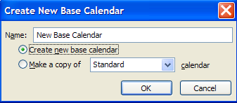

## Setting Working Hours and Days



After the base calendar has been created, decide what the working days (business days) of the project schedule will be. Decide also, how many hours will make up a working day and what times the hours will be. By default, the working days of the calendar are Monday through Friday and the working time is 8:00 am to 12:00 pm and 1:00 pm to 5:00 pm daily or 8 hours working per day.

Ask yourself, how many hours per day do you feel your resources work productively on project work?

The average amount of productive project time in a day for a full time resource is 6 to 6.5 hours. If you are planning projects using an 8 hour day and your resources produce 6.5 hours per day are you planning an unreasonable timeline for your project schedule. After resources are assigned to tasks, the resource availability calendar will be considered in the scheduling equation and the timeline for the project schedule will alter substantially. It is expected that schedules will double in length once actual resources are assigned to tasks.

This difference to the schedule may be handled through adjustments to the project calendar, to the assignments or to the resource calendars. Consider choosing one of the methods and using it as the standard for scheduling projects. Each of the above options has their pros and cons, but it is the crossing of methods that will result in unreliable results in planning a schedule.

To Change the Working Hours of all Days on a Calendar:

1. Click **Project** 🡪 **Change Working Time**
2. Check to ensure the calendar you wish to change is displayed in the **For calendar**list
3. Click **Work Weeks** near the bottom of the dialogue box

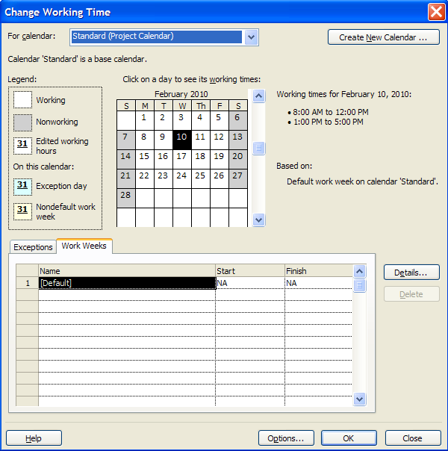

1. After clicking on the **Work Weeks** tab, the word *Default* should be highlighted. Click the **Details** button to the right of the form
2. Click **Monday**, press and hold the shift key and click on **Friday**. All of the working days will be selected
3. Click the **3rd radio button**, **Set day(s) to these specific working times**
4. You will see the standard working times. Make changes to reflect the new values
5. Click **Enter** or **Tab** to move away from the value you have changed
6. Click **OK** to close the form

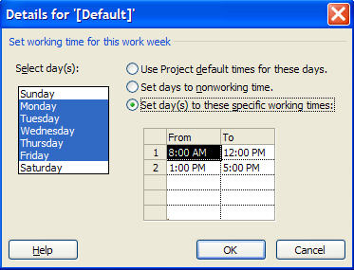

**TIP:** Military time is valid when entering hour values. To change 5:00 pm to 4:00 pm to shorten the work day, simply enter **16** where 5:00 pm is located and click **Enter** or **Tab** and 4:00 pm will appear.

## Setting Non-Working Hours and Days



Non-working time is defined in the software as days where work will not be planned or performed. Examples are: national and organizational holidays, training days, company shutdowns, summer hours, etc. Adding these non-working days and times to the project calendar will allow for the scheduling of the tasks to be excluded from these dates.

A frequently asked question is: Is there the ability to add holidays to a calendar the way they can be added in Outlook? The answer is no - this is not a capability of the software. However, creating recurring holidays and non-working times is a feature of Project 2010.

How to Create a Non-working Day for a Calendar:

1. Click **Project** 🡪 **Change Working Time**
2. Check to ensure sure that the calendar you wish to change is displayed in the **For Calendar** field
3. Click **Exceptions** tab near the bottom of the dialogue box

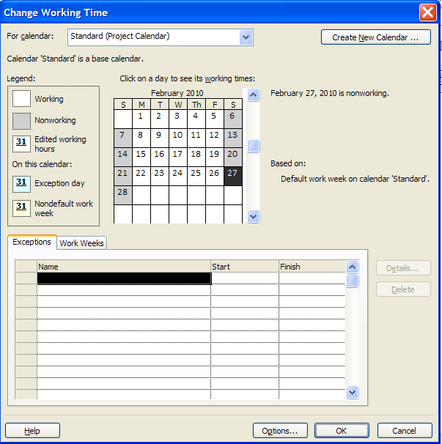

1. In this example, we will set April 8, 2011 as a non-working day. Move the slider on the right side of the calendar down until **April 2011** is displayed in the calendar
2. Click **April 8, 2011**
3. Click in the name field and enter a reason for the non-working day, ie: Company holiday
4. Click **Enter**
5. Repeat for additional non-working days. See the result below

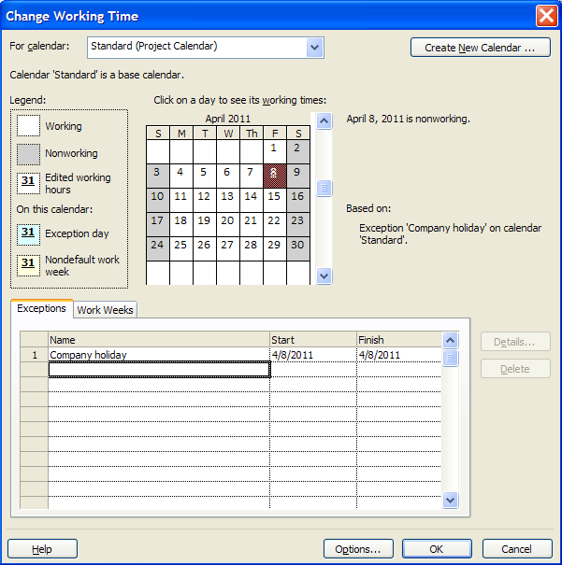

To Create a Recurring Non-working Day for a Calendar:

1. Click **Project** 🡪 **Change Working Time**
2. Check to make sure that the calendar you wish to change is showing in the **For calendar**field
3. Click **Exceptions** the tab near the bottom of the dialogue box
4. In this example, we will set January 1 (New Year’s Day) as a recurring non-working day. Move the slider on the right side of the calendar down until **January 2013** is displayed on the calendar
5. Click **January 1, 2013**
6. Click in the first open line in the **Name** field and enter **New Year’s Day** for the non-working day
7. Click **Enter**
8. Click back on the words **New Year’s Day** and then click on the **Details** button to the right of the form
9. Click **Yearly**
10. Click on January 1
11. Enter the start date
12. Enter a recurrance value or an End by date
13. Click **OK** to close box
14. Check for the recurrance values in the Exceptions line for New Year’s Day.

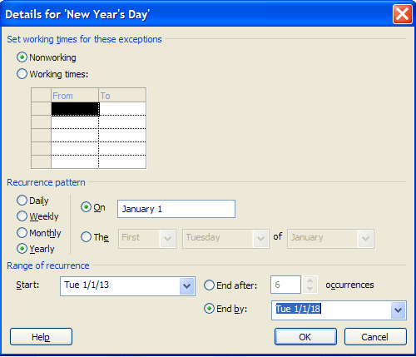

## Setting Calendar Options



The Calendar options work hand in hand with the project calendar to determine how tasks will be scheduled. It is imperative that the calendar options match the project calendar to create a consistency in the scheduling values for tasks and assignment values.

To access the Calendar options:

**Click File 🡪 Options 🡪 Schedule**

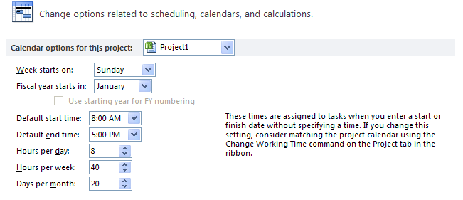

What the options mean:

* **Calendar options for this project:** option to select whether your option choices for the calendar will be held within an individual project or if they will be applied to all new projects.
* **Week starts on:** this choice will affect what is assigned and viewed as the first day of the week. The day chosen will be reflected on the Gantt Chart, Resource Usage, Task Usage and other calendar views.
* **Fiscal Year starts in:** if using this option, select which month will be the start of the fiscal year.
* **Default start and end times**: these values should match the time values on the project calendar. Assigning the project calendar will be discussed in the next lesson. The times stated here will be used to schedule tasks when time is not specified for a task. It will also be used to schedule tasks that do not use relationships. For example: if recurring tasks are created, the tasks will always be scheduled at the start time represented in this option.
* **Hours per day:** when 1 day of work is scheduled, how many hours should 1 day consist of?
* **Hours per week:** when 1 week of work is scheduled, how many hours should 1 week consist of?
* **Days per month:** when 1 month of work is scheduled, how many days should 1 month consist of?

## Saving the Calendar



In Project 2010, the calendar that was just created is known as a “custom object”. Custom or customized objects may be saved for use in the project the object was created in and used in other projects as well. To save objects the Organizer is used. When Project 2010 was installed on your system, a file named Global.mpt was created. The Organizer is the function that will copy objects into the Global.mpt as well as between project schedules. Calendars are only one of many object types that may be customized and saved for use in other project schedules. The other objects will be discussed in Module 10. In this lesson, we will only address the Calendar.

To save the custom or customized calendar, the object must be copied using the Organizer.

To copy a New Base Calendar into the Global.mpt:

1. Click **File 🡪 Info 🡪 Organizer**
2. Click the **Calendars** tab
3. Click **New Base Calendar** to the right and click <<**Copy**
4. Click Cancel to close the box

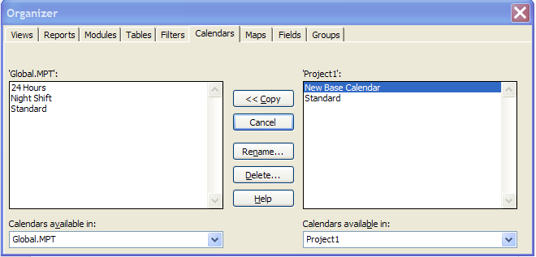

The Calendar will be copied into your local Global.mpt.

## Practice: Creating Calendars



*The Practice page is where you write detailed instructions for completing work listed as Exercises.*

*Type the Exercise Title and write a brief summary what the student will be doing in the exercise. Then list your ideas what they will be doing.*

*SAMPLE*

*In this practice you will create a Project Server Authentication profile and then configure the local cache settings in Project Professional 2007.*

*Exercise 1: Create Project Server Authentication Profile*

*In this exercise you will create Project Server authentication profile to connect to the Project Web Access site.*

Perform the following exercise on the PS07 virtual machine.

1. *From the* ***Start*** *menu, click* ***All Programs*** *🡪* ***Microsoft Office*** *🡪* ***Microsoft Office Tools*** *and click* ***Microsoft Office Project Server 2007 Accounts****.*
2. *In the* ***Project Server Accounts*** *dialog box, click* ***Add****.*
3. *In the* ***Account Properties*** *dialog box, and complete the following settings and click* ***OK****.*

|  |  |
| --- | --- |
| *Setting* | *Perform the following:* |
|  | |
| *Account Name* | *Type* ***Project Server*** |
| *Project Server URL* | *Type* ***http://epm/pwa*** |
| *When connecting* | *Select* ***Use Windows user account*** |
| *Set as default account* | *Select check box* |

# Lesson 2: Configuring Schedule/Display Options



Understanding the concepts that are the basis for task and resource scheduling using Project 2010 will help you create schedules easier. The option choices made will depend on the project metrics requirements, the standards of the organization, and it will control standard values within the project schedule. Making educated decisions for these values is the objective of this lesson.

Topics in this lesson are:

1. Configuring Schedule/Display Options
2. Understanding Duration vs. Work / Effort
3. What is Effort Driven Scheduling
4. Understanding Task Types
5. Setting Schedule Options
6. Setting Display Options
7. Adding Project Information
8. Working with Timescale

## Understanding Duration vs. Work / Effort



To understand Project 2010’s schedule engine it is helpful to understand the terms “Duration” and “Work” which is fundamental to understanding project scheduling.

**Definitions:**

* Duration is a length of time ie: a day, a week, or a month
* Work is the quantity of work that occurs ie: 8 hours in one day, 40 hours in a week

For example:

How many people are in this room? ______________________

How long are we here for today?______________________

Number of people in the room x number of hours in the day

= Quantity of work performed today.

If more people come in the room, will the duration of the class day change? No

Will the number of hours of work change? Yes because more people are working

The number of hours of work is a function of how many people are performing the work and might not affect the duration of a task.

Work and effort are interchangeable terms. In Project 2010 Help, and other reference books, you will see work referred to as effort.

## What is Effort Driven Scheduling?



Tasks have the option of being scheduled using Effort-driven scheduling. Effort-driven is defined as when more workers are added, the effort (or work) will be divided across the workers.

For example: A project has a task called “Moving boxes”. The work of the task is to move 100 boxes from location A to B. If one person moves the boxes, it will take 10 hours of duration. However, if 2 people move the boxes it will take 5 hours, 3 people can accomplish this task in one-third of the original time, etc. In theory, if 100 people move the boxes, we will get the task completed in a few minutes. In this scenario, however, all work is equal. Does it matter which box a worker moves? If one worker becomes unavailable, can the other workers move the rest of the boxes? This is effort-driven scheduling.

Another example is driving a car: If it takes 5 hours to get from point X to point Y, can you get there faster if you add more drivers to the car? This task by nature is not effort-driven because there is really only one worker who can perform the task at a time.

The following examples show that effort-driven scheduling will not apply to all tasks. Each task should be examined to determine if effort-driven scheduling applies and the setting altered on a task by task basis.

## Understanding Task Types



Each task will be assigned a task type when the task is added to the schedule. Task types work hand-in-hand with the effort-driven option discussed on the previous page. Task types determine how a task is scheduled and will have an effect on the assignment of the resources. Task types should be considered unique per task and should be set on a task by task basis.

The software allows for the following 3 task types:

* **Fixed Duration:** A fixed duration task is a task created with a fixed length of time. Fixed Duration tasks are also tied to dates.   
    
  Example: This training class. When the time for the class is over, the work of the class is completed. If someone leaves the class for a meeting, they cannot come the day after the class is completed to make up the work they missed.
* **Fixed Units:** Units means quantity of resource. Fixed Units means that the resource assignment quantity is fixed for the task. Using this task type will result in the quantity of the units assigned to a task coupled with the availability of the resource to determine the scheduling of the task.   
    
  Example: If it takes 5 hours to drive from point X to point Y, and the driver (the resource) is available for the full 5 hours per day, it will take 1 day to get from point X to point Y. If the driver is available for 2 and a half hours per day or 50% of his availability, it will take 2 days to drive the same distance. If the driver is available for only 1 hour per day (20%), it will take 5 days to drive from point X to point Y. If there is a weekend in the middle of the task and a non-working day for the resource, it could take a lot longer to get to point Y.
* **Fixed Work:** The work of the task is fixed. Fixed work tasks, by default, are also effort-driven. The more resources assigned to the task, the less time the task will take to be completed. Fixed work tasks will be scheduled based on the quantity of the units of the resources assigned to the task and their availability based on their resource calendar.   
    
  Example: If a task called “Plan event“, and has 80 hours of work, the work will be completed in 2 weeks with 1 full time resource. If a second resource is added full time, the task will be completed in 1 week. Each resource would have performed 50% of the work. The more resources, the faster the work is completed.

When task types are coupled with the effort-driven option, the scheduling engine allows for 5 combinations of task type, effort-driven combinations:

* Fixed Duration, Effort-driven on
* Fixed Duration, Effort-driven off
* Fixed Units, Effort-driven on
* Fixed Units, Effort-driven off
* Fixed Work, Effort-driven on

The project options will allow for setting a default that each task will be assigned when the task is entered. It should be noted that each task is different and unique. The default should be considered a starting point. The schedule developer should get to know the tasks and the work of the tasks and reset the task type and effort-driven options on a task by task basis.

## Setting Schedule Options



Scheduling options are per project options which establish the defaults how a project will be scheduled. These options are unique per project and should be checked before entering tasks into a project schedule. These options also may be changed at any time over the life of the project schedule.

To set the scheduling options:

Click File 🡪 Options 🡪 Schedule

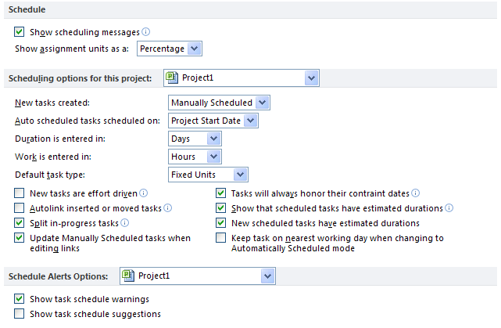

* **Show scheduling messages:** gives the scheduler error messages concerning scheduling inconsistencies and warnings.
* **Show assignment units as a:** options are percentage or decimal. This is user preference. It may be changed at any time without affecting the schedule.
* **Scheduling options for this project:** options that can be assigned to a specific project or all projects.
* **New tasks created:** manually scheduled or automatically scheduled. This is the default value and may be adjusted per task.   
  + **Manually scheduled**: tasks will be entered without a start or finish date and without task duration. All values are entered manually.
  + **Auto scheduled:** tasks will be entered with a default duration of 1 day and a start and finish date.
* **Auto scheduled tasks scheduled on:** project state date or current date. If you are managing a long project it might be easier to change this option for all new tasks to start on the current date.
* **Duration is entered in:** minutes, hours, days, weeks, months
* **Work is entered in:** minutes, hours, days, weeks, months
* **Default task type:** Fixed Units, Fixed Duration, or Fixed Work
* **New tasks are effort driven:** check for yes
* **Update Manually Scheduled tasks when updating links:** when tasks are manually scheduled should the project schedule successor tasks based on realtionship links

**TIP:** it is a good idea within an organization to establish a standard for Duration and Work. When duration is discussed or appears on a report it will be easier for stakeholders to understand that duration always means hours or the value that works for the specific project. If you have a 3 year project, you probably will not be planning work at the hour level so weeks might be the duration standard.

## Setting Display and General Options



General options are options which affect how the installation of Project 2010 on a desktop will operate. Display options are options that will help the user interface with Project 2010 software. The options selected are unique to each user and are a personal preference. These options do not have an influence on the ability to create a project schedule.

To navigate to General options:

Click **File 🡪 Options 🡪 General**

In the Project view section, the user may select the default view for usage of Project 2010 and the date format for dates for reports and views (tables).

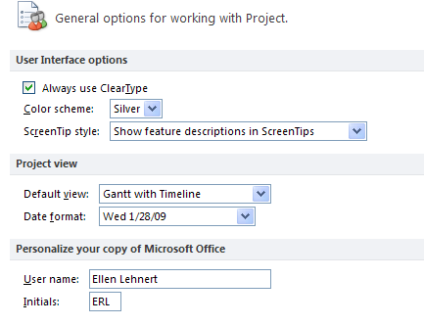

To navigate to Display options:

Click **File 🡪 Options 🡪 Display**

These options refer to which elements should be viewed on the screen. These options will control which indicators are shown in the indicator column, currency values and if the Entry bar is visible or not.

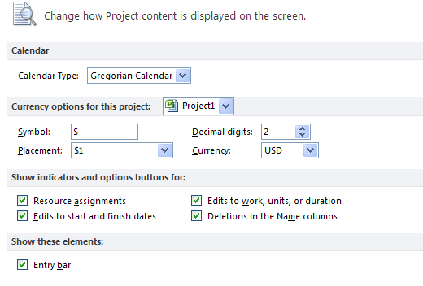

Additional display options are available at:

Click **File 🡪 Options 🡪 Advanced**

Some of the options that should be considered are:

* **Show this number of recent documents** – optional number, list will show in the Recent tab in the backstage
* **Automatically add new views, tabls, filters and groups to the global**  - recommended
* **Settings for duration label values** – Minutes, Days, etc. - may alter as needed
* **Show project summary task** – recommended

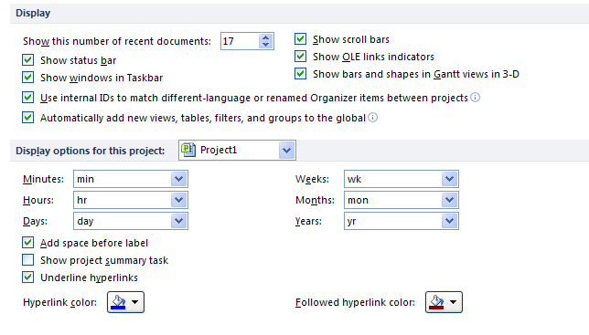

**Best practice:** Each project schedule has the ability to contain a Project Summary task. The Project Summary task is a zero level task that will serve as a constant grand total for the project schedule. The setting in the above options may be used to turn on the project summary task or use the directions below.

To turn on the Project Summary task:

Click **Task 🡪 Gantt Chart**

Click **Format 🡪 Project Summary Task** (on the right side of the ribbon)

## Adding Project Information



The final project information that should be entered before proceeding with project schedule development is the project start or project finish date as well as indicating which calendar will be used as the project calendar. This information is entered through the Project Information box.

To navigate to the Project Information dialogue box:

Click Project 🡪 Project Information

Deciding whether to enter the Project Start date or the Project Finish date will take some consideration. There are pros and cons to either choice:

**FAQ:**  Should I enter a project start and finish date?

**Answer:**  Project 2010 will accept either the start or the finish date but not both.

Entering a start date will indicate that you are planning your schedule as forward scheduling. This will result in:

* All tasks will be scheduled As soon as possible
* The work of the project will determine the project ending date
* You will have a date to manage to and know when you are on time or late with the progress of the project

Entering a finish date will indicate that you are planning your schedule as backward scheduling. This will result in:

* All tasks will be scheduled As late as possible
* The ending date of the project will be locked to a date on the calendar
* You might be planning a project where each task will be required to be completed as planned to achieve the ending date goals.

The most used planning method is that projects are planned from the project start date.

**Project Calendar:** The default calendar is “Standard”. Whatever calendar is selected will become the scheduling calendar for the project. All tasks will be scheduled using this calendar until a resource is assigned to the task.

Click **OK** to close the box.

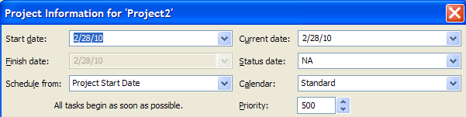

.

**TIP:** Most project managers have definite deadlines. Consider planning the schedule from ending date to get the schedule short term goals, deadlines and milestone dates. Then switch the project to the start date to manage. Reset the constraints to as soon as possible to enable the schedule to include slack and aid in schedule management.

## Working with Timescale



Timescale is the calendar density that is viewed in all Gantt Charts, Resource Usage, Task Usage and other calendar based views. It is the calendar line that runs on the right side above the Gantt bars at the top of the view. Adjustments to the timescale will allow for viewing time in different time increments such as by week by day or by month by week. As views are changed, the timescale should be adjusted to fit your needs.

Project 2010 provides several methods to adjust the timescale:

The easiest way to adjust the scale is new to Project 2010. Use the sliding adjustment in the lower right corner of any view.



Another way to change the timescale is on the **View** tab on the ribbon. On the right side are adjustments for the timescale:

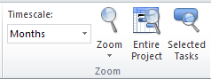

More detail about defining the timescale can be found in the Timescale dialogue box. Double click on the timescale (the date line above the Gantt bars) and the dialogue box below will appear:

For project schedules using a fiscal year: under **Timescale options**, **Show**: select **Three tiers** and define the top or third tier. Adjusting the timescale using this form will work best starting at the Bottom Tier and working your up way through the Middle and Top Tiers at avoid errors. As changes are made, a sample of the result in shown the bottom of the box.

Click **OK** to close the box.

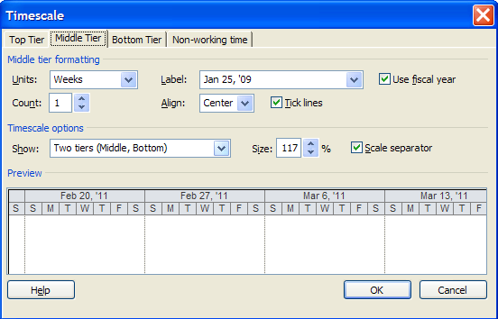

## Practice: Configuring Schedule/Display Options



*The Practice page is where you write detailed instructions for completing work listed as Exercises.*

*Type the Exercise Title and write a brief summary what the student will be doing in the exercise. Then list your ideas what they will be doing.*

*SAMPLE*

*In this practice you will create a Project Server Authentication profile and then configure the local cache settings in Project Professional 2007.*

*Exercise 1: Create Project Server Authentication Profile*

*In this exercise you will create Project Server authentication profile to connect to the Project Web Access site.*

Perform the following exercise on the PS07 virtual machine.

1. *From the* ***Start*** *menu, click* ***All Programs*** *🡪* ***Microsoft Office*** *🡪* ***Microsoft Office Tools*** *and click* ***Microsoft Office Project Server 2007 Accounts****.*
2. *In the* ***Project Server Accounts*** *dialog box, click* ***Add****.*
3. *In the* ***Account Properties*** *dialog box, and complete the following settings and click* ***OK****.*

|  |  |
| --- | --- |
| *Setting* | *Perform the following:* |
|  | |
| *Account Name* | *Type* ***Project Server*** |
| *Project Server URL* | *Type* ***http://epm/pwa*** |
| *When connecting* | *Select* ***Use Windows user account*** |
| *Set as default account* | *Select check box* |

# Lesson 3: Creating and Saving a Project Schedule



x

At this point we are ready to new create a project. Project schedules may be started in multiple ways. If your options have been saved for “All Projects” you may use some of the importing functions to allow tasks from SharePoint lists (Pro 2010 only) or Excel to be brought into a new schedule. Creating projects using templates is an easy way to build project schedules faster.

The topics to be discussed in this lesson are:

1. Creating a Project
2. Creating a Project from an Excel Workbook
3. Creating a Project from a SharePoint Task List
4. Importance of Naming Standards
5. Setting Read-Only and Password Attributes
6. Saving the Schedule
7. Saving and Sending Options

## Creating a New Project



When Project 2010 is initiated, a new blank project schedule will automatically appear.

To create a blank project schedule:

* Click **File** 🡪 **New**

Backstage choices shown below will give you an array of choices of where to begin a new project schedule. As you click the various choices, options and additional data will appear on the right side of the view.

* Double clicking **Blank project** or click **Blank project** and click **Create** will result in creating a blank project file
* **Recent Templates:** Create a project from a recently used template
* **My templates:** Template created my you and saved to your desktop
* **New from an existing project:** Use an existing project schedule to create a new project
* **New project from Excel workbook:** Columns in the Excel workbook will be mapped to fields within Project 2010. The import process is discussed in the next lesson.
* **New from Sharepoint task list:** Project 2010 Professinal only. Tasks will be imported using the URL and security of the Sharepoint site.
* **Office.com templates:**  Create a new project from a template that would be downloaded from Office.com on-line
* If the Quick Access Bar was customized to add the **New** button, pressing that button will create a new project schedule

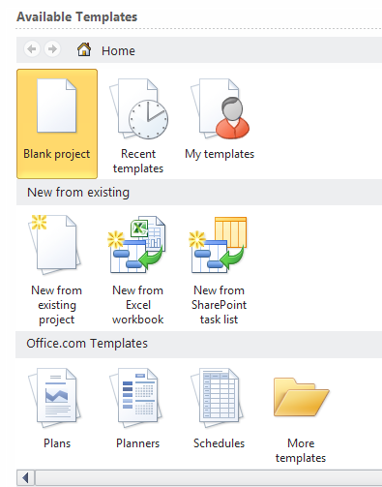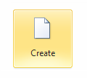

## Creating a Project from an Excel Workbook



A project schedule can be created using an Excel Workbook task list. Keep in mind that the fields or columns that are being imported from Excel will be mapped to fields or columns within Project 2010. Pre-planning to know which Excel fields should be mapped to which Project 2010 fields would be helpful.

**NOTE:** All options should be pre-set before importing tasks.

To create a project schedule from an Excel Workbook:

1. Click **File 🡪 New 🡪 New From Excel Workbook**
2. Navigate to the Excel file that contains the tasks to be imported into the schedule, click **Open**
3. Project 2010 Import Wizard will start running – Click **Next**
4. Select whether to use a new map that will be created or an existing Project import map. For this example we will create a new map. Click the radio button next the **New Map** and click **Next**
5. Import can start a new project file, append to the end of an existing project file or merge the data using a merge field. In this example we will create a new project schedule. Click **As a new project** and click **Next**.
6. When the data is brought into Project 2010, select if the data is to be mapped to the Task fields, Resource fields or Assignment fields. Click **Tasks**.
7. If the originating Excel file contains header or title information, click **Import** **includes Headers**. The system will remove this row (the first line only) as the header row. Click **Next**
8. The Task Mapping form will be used to view some of the data and map which Excel fields will be imported into which Project 2010 fields. Pull down the values in the **Select worksheet name** option and select the sheet name in Excel that contains the data to be imported. After the choice has been made, the data from the sheet will be available for viewing.
9. In the example below, the duration field from the Excel Workbook was able to be automatically mapped to the duration field in Project 2010. However, the Task Name field could not find a match. The correct field name for the task name field in Project 2010 is “Name”. Click the red error message (**not mapped)** and select the field name of **Name**. Repeat for other fields to be imported. Not all fields are required during the import process which allows the user to pick and choose which ones are appropriate to the schedule. Click **Next** to continue after all columns have been mapped.

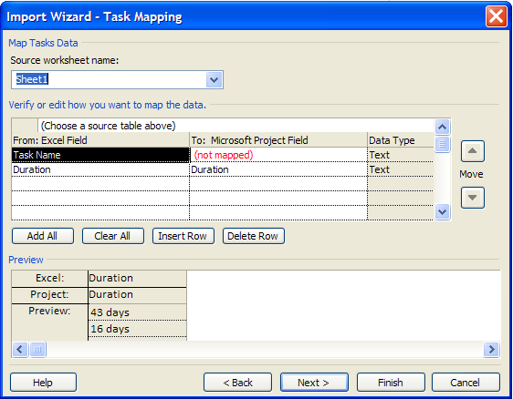

1. The next step offers the option to save the map for future reuse.
   1. To skip saving the map, click **Next**.
   2. To save the map, click **Save Map** and give the map a name.   
      An option will be available to use the Organizer to copy the import map into the Global.mpt and save it for future use. The Organizer will be discussed in Module 10.   
      Click **Finish** to start the import.
2. The new Project 2010 schedule will open with the columns imported.

## Creating a Project from a SharePoint Task List



Project 2010 Professional allows for creating a new project by importing a task list from a SharePoint site. The user must have appropriate permissions to the access the SharePoint site and the URL path to insert into the form directing Project 2010 Pro to the location of the task list.

To import tasks from a SharePoint task list into Project 2010 Professional:

1. Click **File 🡪 New 🡪 New** from SharePoint Task List

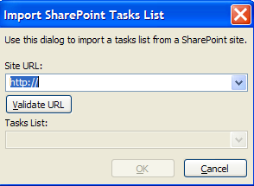

1. Enter the **URL** in the form as shown above and click **Validate URL**. A list of all the task lists included in the SharePoint site will be displayed. Select the appropriate list and click **OK**.

The list will be imported from the SharePoint site.

**NOTE: –this is Pro only – Rolly should add a screen shot here.**

## Importance of Naming Standards



The project name is an important consideration of the project. If given the option of naming a project, project managers will name the project whatever is comfortable for them. The name that is chosen is not necessarily comfortable for other users and viewers of the project schedule. Consideration should be given around how the project name will and should be used. Each organization should have a naming convention for projects.

Popular poor choices for project names:

* Projects named after chili peppers
* Projects named after cars
* Projects named after project managers or that include the project manager name
* Abbreviations that make sense only to the person naming the project
* Internal company speak
* 254 character project names

Popular good choices for project names:

* Project names based on what the project actually is
* 50 characters or less
* Client name, short project name, known code for new development or enhancement
* Standardized abbreviations: department name, location, short project name
* Select a name that is easily recognizable and understandable

It should be noted that project names will be seen and used in:

* Columns on reports – this will be necessary if any report will contain tasks from multiple projects.
* Header and footers for reports
* Multiple uses in Project Server 2010

## Setting Read-Only and Password Attributes



When a project is saved, it may be necessary to set the project schedule as read-only to guard against other users changing attributes and data in the project schedule. Another security layer is the ability to assign a password and to always have a backup copy of the schedule created when the schedule is opened.

To set the read only and security passwords for a project schedule:

1. Click **File 🡪 Save as 🡪 Tools** (lower left of the Save As form) the following dialogue box appears:

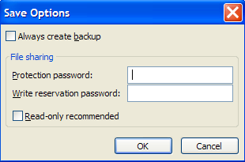

1. **Always create backup**: If checked a backup of the project schedule will be created each time the project is opened. No changes will be made to the original project schedule file.
2. **Protection password:** will guard against someone opening and viewing the project schedule without the password.
3. **Write reservation password:** guards against someone opening the project schedule in write mode. If the user has the first password only, they are allowed to open the schedule in read-only mode.
4. **Read-only recommended:** when checked and the file is opened the following message will appear:

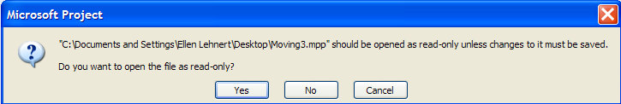

At this point the user may select to **Yes** or **No** to open the file as read-only. Cancel results in the file not being opened.

## Saving the Schedule



Project 2010 provides multiple file formats for a project schedule. The steps to save a file are very similar to other MS Office files.

To save the Project 2010 schedule:

1. Click **File 🡪 Save as 🡪 select file location**
2. Enter the file name in the File Name area
3. Click **Save** to complete the save. The file will be given a Project 2010 default file extension of .mpp

There is also an option to save the Project 2010 schedule in an alternative file format. Some of the formats are:

* MS Project 2007
* MS Project 2000-2003
* MS Project template 2010 - .mpt file extension
* MS Project template 2007 - .mpt file extension
* MS Excel
* PDF
* XPS
* XML
* CVS
* Text

## Save and Send Options



A new feature in Project 2010 is the Save and Send from the backstage view. These options are an easy method of saving projects and sharing project schedules with others. There is also an option to send project files as an attachment to an email as well as publishing the project schedule to a SharePoint site (Project 2010 Pro users only).

To navigate to the options available for Save and Send:

* Click **File 🡪 Save and Send 🡪 select one of the options offered**

**NOTE:** the right side of the screen will change as options are selected

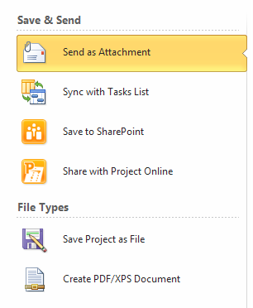

* **Send as Attachment:**  sends the project schedule as an attachment to an Outlook email
* **Sync with Tasks List:** use this option to synchronize with a task list in SharePoint. Team members can update task status and the updates can be synchronized back to the project schedule. The URL to the SharePoint site and the task list name will be needed at the time of the synchronization.
* **Save to Sharepoint:** this option will save the project schedule to a Sharepoint site. (Project 2010 Pro users only)
* **Share with Project Online:** used with Project Server and SharePoint  
    
  **Save Project as a file: wh**en clicked the right side of the view is shown below. There a**re several file type opti**ons available. Click **Project** and **Save As** to start the save process.

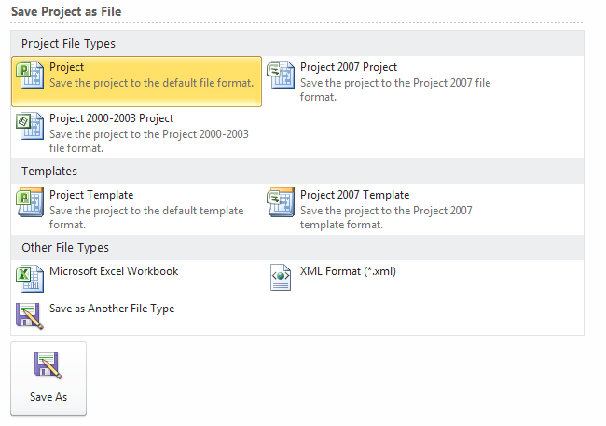

* Create a PDF/XPS document: Click Create PDF/XPS, name the file and select PDF or XPS, click OK to complete the save.

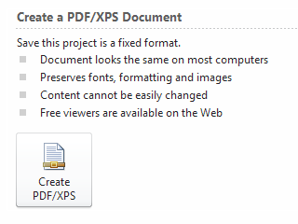

## Practice: Creating and Saving a Project Schedule



*The Practice page is where you write detailed instructions for completing work listed as Exercises.*

*Type the Exercise Title and write a brief summary what the student will be doing in the exercise. Then list your ideas what they will be doing.*

*SAMPLE*

*In this practice you will create a Project Server Authentication profile and then configure the local cache settings in Project Professional 2007.*

*Exercise 1: Create Project Server Authentication Profile*

*In this exercise you will create Project Server authentication profile to connect to the Project Web Access site.*

Perform the following exercise on the PS07 virtual machine.

1. *From the* ***Start*** *menu, click* ***All Programs*** *🡪* ***Microsoft Office*** *🡪* ***Microsoft Office Tools*** *and click* ***Microsoft Office Project Server 2007 Accounts****.*
2. *In the* ***Project Server Accounts*** *dialog box, click* ***Add****.*
3. *In the* ***Account Properties*** *dialog box, and complete the following settings and click* ***OK****.*

|  |  |
| --- | --- |
| *Setting* | *Perform the following:* |
|  | |
| *Account Name* | *Type* ***Project Server*** |
| *Project Server URL* | *Type* ***http://epm/pwa*** |
| *When connecting* | *Select* ***Use Windows user account*** |
| *Set as default account* | *Select check box* |

# Summary



Laying the basis for how a project schedule will function is important. Understanding the options and the result of your option choices will help the schedule deliver the value you are hoping to achieve. Forthought and planning will help create the type of schedule needed for managing your project.

In this module you learned how to:

* Create project calendars and the options that work with the calendars.
* Save a customized calendar for use by other project schedules
* Scheduling terms: Effort-driven, Fixed Duration, Fixed Work and Fixed Units
* Set the scheduling options
* Create projects from templates, SharePoint lists and Excel lists
* Establish naming conventions for project schedules
* Set security passwords for project schedules